TORQUEWARE 2.0 ADMINISTRATIVE PORTAL USER GUIDE
Revision 1.0 Date: 5/5/2014

TABLE OF CONTENTS

Tools ……………………………………………………… page 3  - Adding a new tool  - Editing a tool  - Deleting a tool  - Printing a tool sticker  - Managing tool groups  - Printing a tool group sticker  Calibrations …………………………………………... page 6  - Adding a calibration  - Editing a calibration  - Deleting a calibration  - Exporting calibrations  Repairs ………………………………………………..… page 8  - Adding a repair  - Editing a repair  - Deleting a repair  Service Tickets ………………………………………. page 9  - Adding a service ticket  - Editing a service ticket  - Deleting a service ticket  - Managing product categories  - Managing products | Customers ………………………………………………… page 11  - Adding a customer  - Editing a customer  - Deleting a customer  - Managing customer users  Technicians ……………………………………….……… page 13  - Adding a technician  - Editing a technician  - Deleting a technician  Users ………………………………………………………… page 14  - Adding a user  - Editing a user  - Deleting a user  Manufacturers ……………………………………….…. page 15  - Adding a manufacturer  - Editing a manufacturer  - Deleting a manufacturer  Locations ………………………………………………….. page 16  - Adding a location  - Editing a location  - Deleting a location  - Managing location equipment

MANAGING TOOLS
Adding a New Tool
To add a new tool, click on the TOOLS link in the top main menu then, click on the ADD TOOL button in the upper right corner. This will bring up a form to create a new tool in Torqueware (see image).
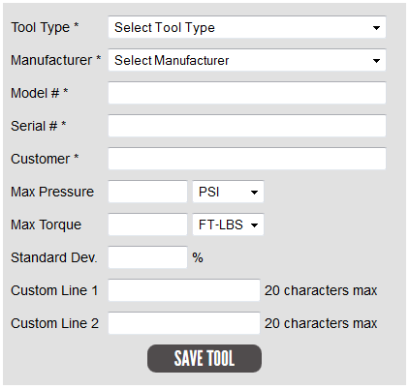
Select the proper tool type and manufacturer from the drop down menus and enter the model # and serial #. To attach this tool to the proper customer, begin entering the customer name and a list of possible custom matches will appear to select the correct customer. Depending on the tool type, enter the maximum torque and pressure values and select the correct units of measurement for each. Then enter the manufacturers stated standard deviation. The optional custom line fields pertain to the tool sticker and allow for two text lines to be added to the bottom of the tool sticker for things like adding the serial # and/or average multiplication ratio, etc. Once you have finished filling out the form, click on the SAVE TOOL button and the tool will be saved and you will be redirected to the View Tool page for the new tool.
Editing a Tool
To edit an existing tool, begin by searching for the tool, either by the unique tool id # or a combination of other search criteria until it is listed in the tools list. Once you have found the tool you wish to edit, click on the edit icon (pencil and paper icon) on the right side of the tool record. This will bring up a form to edit the tools information. After making any changes to the tools information, click on the SAVE CHANGES button and the changes you have made will be saved and you will be redirected to the View Tool page for the updated tool.
Deleting a Tool
To delete an existing tool, begin by searching for the tool, either by the unique tool id # or a combination of other search criteria until it is listed in the tools list. Once you have found the tool you wish to delete, click on the delete icon (the x icon) on the right side of the tool record. This will bring up a confirmation box asking if you are sure you want to delete the tool. If you are sure, click on the OK button.
Printing a Tool Sticker
From the View Tool page of a tool, click on the PRINT TOOL STICKER button in the upper right corner. This will bring up a page the shows an image of the tool sticker (see image).

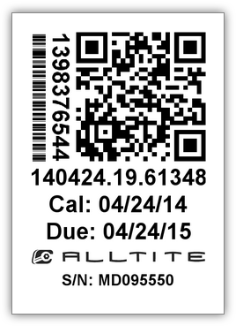

Click on the image and it will prompt you to open or save a pdf version of the sticker. Select “Open with Adobe Acrobat” and once it opens, hit Ctrl + P to print. You will need to select the Brady TLS PC Link printer, and ensure that the “Choose paper source by PDF page size” checkmark is checked. Then click print and the sticker will be printed from the label printer.

Managing Tool Groups
To manage tool groups, first click on the TOOLS link in the top main menu then, click on the MANAGE TOOL GROUPS button in the upper right corner. This will bring up a list of tool groups which you can edit or delete. To add a new group, click on the ADD TOOL GROUP button in the upper right corner. This will bring up a form to create a new tool group in Torqueware (see image).
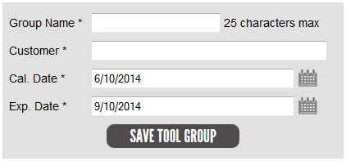
Enter a name for the group. To attach this tool group to the proper customer, begin entering the customer name and a list of possible custom matches will appear to select the correct customer. Next select the date the group is to be calibrated and when the calibration interval expires. Once you have finished filling out the form, click on the SAVE TOOL GROUP button and the group will be saved and you will be redirected back to the View Tool Group page for the group.
To add tools to a tool group, from the View Tool Group page, click on the ADD TOOLS TO GROUP button on the right side below the tool group information. This will bring up a form to filter and select the tools you want to group (see image).
Choose a combination of tool id #, tool types, manufacturer, model or serial # and/or a specific customer and click FILTER. This will generate a list of tools matching your filter criteria and buttons to submit the form (see image).
Either select the specific tools to add and click the ADD SELECTED TOOLS TO TOOL GROUP button, or if you want to add all of the tools in the list, click on the ADD ALL ## TOOLS TO TOOL GROUP button.
Printing a Tool Group Sticker
From the View Tool Group page of a tool group, click on the PRINT TOOL GROUP STICKER button in the upper right corner. This will bring up a page the shows an image of the tool group sticker (see image).

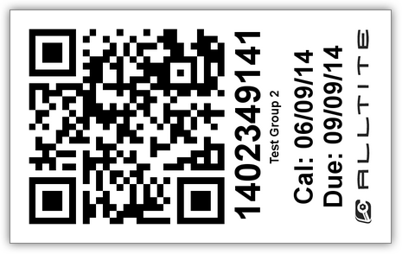

First, click on the "Download Label Template" link. Choose "Open with Microsoft Word" when prompted. Click "Enable Editing" button in yellow warning bar at top of Word Document. Click and drag the Tool Group Sticker from the web browser to your desktop. Drag image file from your desktop onto one of the spaces in the Word Document. Load a label sheet into printer and then click Print.

MANAGING CALIBRATIONS
Adding a New Calibration
To add a new calibration, click on the CALIBRATIONS link in the top main menu then, click on the ADD CALIBRATION button in the upper right corner. This will bring up a form to create a new calibration in Torqueware (see image).
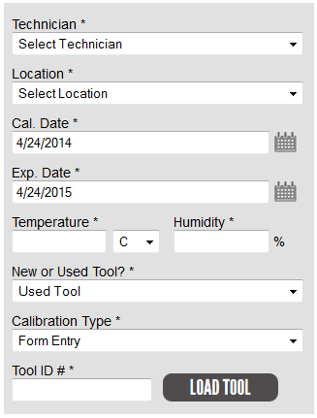
Select the proper technician and location from the drop down menus and enter the current temperature and humidity. Then select whether you are calibrating a new or used tool and whether you are using the form entry or uploading a third party calibration certificate. Finally, enter the tool ID # for the tool you are calibrating and click the LOAD TOOL button. If you selected Form Entry as your calibration type, a form will be displayed to enter the data for the calibration depending on the tool type. Fill out the readings and select the “As Found” and “As Left” results, then select the specific location equipment that was used for the calibration. Once you have finished filling out the form, click on the SAVE CALIBRATION button and the calibration will be saved and you will be redirected to the View Calibration page for the new calibration.
Editing a Calibration
To edit an existing calibration, begin by searching for the calibration, either by the unique calibration id # or a combination of other search criteria until it is listed in the calibrations list. Once you have found the calibration you wish to edit, click on the edit icon (pencil and paper icon) on the right side of the calibration record. This will bring up a form to edit the calibrations information. After making any changes to the calibration, click on the SAVE CHANGES button and the changes you have made will be saved and you will be redirected to the View Calibration page for the updated calibration.
Deleting a Calibration
To delete an existing calibration, begin by searching for the calibration, either by the unique calibration id # or a combination of other search criteria until it is listed in the calibrations list. Once you have found the calibration you wish to delete, click on the delete icon (the x icon) on the right side of the calibration record. This will bring up a confirmation box asking if you are sure you want to delete the calibration. If you are sure, click on the OK button.
Exporting Calibrations
To export calibrations, click on the CALIBRATIONS link in the top main menu then, click on the CALIBRATION EXPORTS button in the upper right corner. This will bring up a list of recent exports made by customers and other users. To add a new export, click on the ADD EXPORT button in the upper right corner. This will bring up a form to filter and select the calibrations you want to export (see image).
Choose a combination of date ranges, a specific customer and/or a specific technician and click FILTER. This will generate a list of calibrations matching your filter criteria and a form for the export (see image).
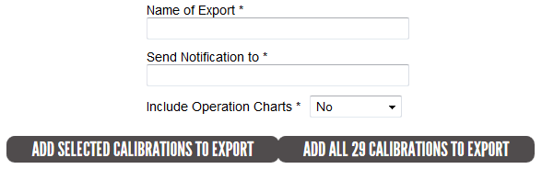
In the form above the calibrations list, enter a descriptive name of the export and an email address to receive the exported files once they have been created. You can also decide whether you want the included operational charts to be exported as well. Then, either select the specific calibrations to export and click the ADD SELECTED CALIBRATIONS TO EXPORT button, or if you want to export all the calibrations in the list, click on the ADD ALL ## CALIBRATIONS TO EXPORT button. This will redirect you back to the export list where it will show your export as pending. The exports are generated once every 10 minutes and you will be emailed a link to download a zip file with the exported calibration certificates in it.

MANAGING REPAIRS
Adding a New Repair
To add a new repair, click on the REPAIRS link in the top main menu then, click on the ADD REPAIR button in the upper right corner. This will bring up a form to create a new repair in Torqueware (see image).
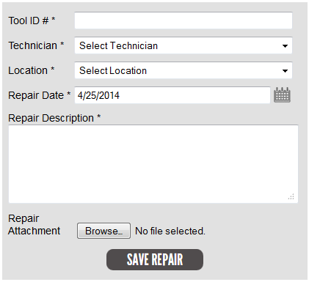
Start by entering the unique tool id # for the tool being repaired. Select the technician and location of the repair from the drop down menus and enter a description for what was done to repair the tool. If you need to attach a quote or some other document click on the Browse button beside repair attachment and locate the file you would like to attach. Once you have finished filling out the form, click on the SAVE REPAIR button and the repair will be saved and you will be redirected to the View Repair page for the new repair.
Editing a Repair
To edit an existing repair, begin by searching for the tool, either by the unique tool id # or a combination of other search criteria until it is listed in the repairs list. Once you have found the repair you wish to edit, click on the edit icon (pencil and paper icon) on the right side of the repair record. This will bring up a form to edit the repairs information. After making any changes to the repair, click on the SAVE CHANGES button and the changes you have made will be saved and you will be redirected to the View Repair page for the updated repair.
Deleting a Repair
To delete an existing repair, begin by searching for the tool, either by the unique tool id # or a combination of other search criteria until it is listed in the repairs list. Once you have found the repair you wish to delete, click on the delete icon (the x icon) on the right side of the repair record. This will bring up a confirmation box asking if you are sure you want to delete the repair. If you are sure, click on the OK button.
MANAGING SERVICE TICKETS
Adding a New Service Ticket
To add a new service ticket, click on the SERVICE TICKETS link in the top main menu then, click on the ADD SERVICE TICKET button in the upper right corner. This will bring up a form to create a new service ticket in Torqueware (see image).
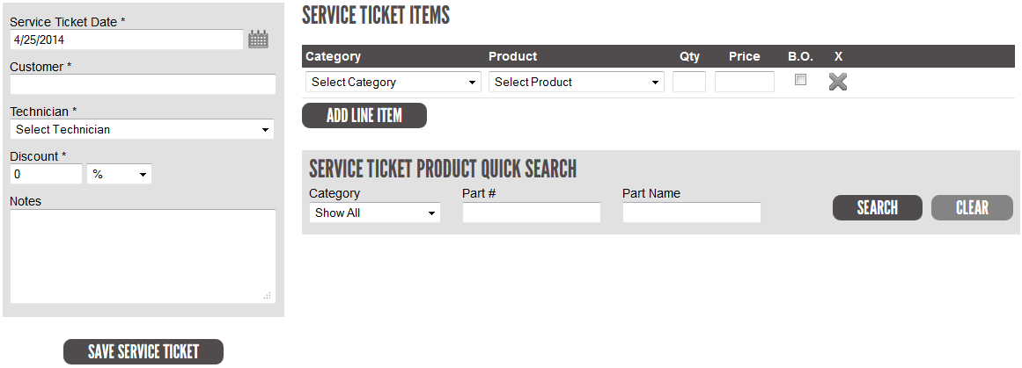
Start by selecting the customer for this service ticket. Begin entering the customer name and a list of possible custom matches will appear to select the correct customer. Select the technician creating the service ticket. The form starts out with a single line item ready to go. Select the category for the product you would like for this line item, and then select the product. This will pre-populate the line item with the price. If you need to add more line items click on the ADD LINE ITEM button and another line item will be added to the form. If you need to reorder the line items, hover over a line item and you will notice up and down arrows on the right side of the line item. Just drag the line item up or down to reorder. Once you have finished filling out the form, click on the SAVE SERVICE TICKET button and the service ticket will be saved and you will be redirected to the View Service Ticket page for the new service ticket.
Editing a Service Ticket
To edit an existing service ticket, begin by searching for the service ticket, either by the service ticket # or a combination of other search criteria until it is listed in the service tickets list. Once you have found the service ticket you wish to edit, click on the edit icon (pencil and paper icon) on the right side of the service ticket record. This will bring up a form to edit the service ticket information. After making any changes to the service ticket, click on the SAVE CHANGES button and the changes you have made will be saved and you will be redirected to the View Service Ticket page for the updated service ticket.

Deleting a Service Ticket
To delete an existing service ticket, begin by searching for the service ticket, either by the service ticket # or a combination of other search criteria until it is listed in the service tickets list. Once you have found the service ticket you wish to delete, click on the delete icon (the x icon) on the right side of the service ticket record. This will bring up a confirmation box asking if you are sure you want to delete the service ticket. If you are sure, click on the OK button.
Managing Service Ticket Product Categories
To manage the service ticket product categories used to organize the products list, first click on the SERVICE TICKETS link in the top main menu then, click on the MANAGE CATEGORIES button in the upper right corner. This will bring up a list of categories which you can edit or delete. To add a new category, click on the ADD CATEGORY button in the upper right corner. This will bring up a form to create a new category in Torqueware (see image).
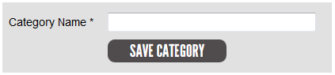
Enter a name for the category. Once you have finished filling out the form, click on the SAVE CATEGORY button and the category will be saved and you will be redirected back to the service ticket category list.
Managing Service Ticket Products
To manage the service ticket product catalog, first click on the SERVICE TICKETS link in the top main menu then, click on the MANAGE PRODUCTS button in the upper right corner. This will bring up a list of products which you can edit or delete. To add a new product, click on the ADD PRODUCT button in the upper right corner. This will bring up a form to create a new product in Torqueware (see image).
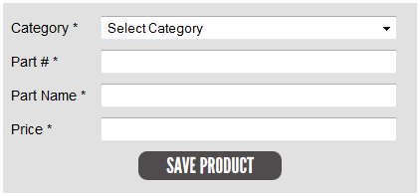
Start by selecting a category to place this product in. Then enter the part #, name and price for the product. Once you have finished filling out the form, click on the SAVE PRODUCT button and the product will be saved and you will be redirected back to the service ticket product list.
MANAGING CUSTOMERS
Adding a New Customer
To add a new customer, click on the CUSTOMERS link in the top main menu then, click on the ADD CUSTOMER button in the upper right corner. This will bring up a form to create a new customer in Torqueware (see image).
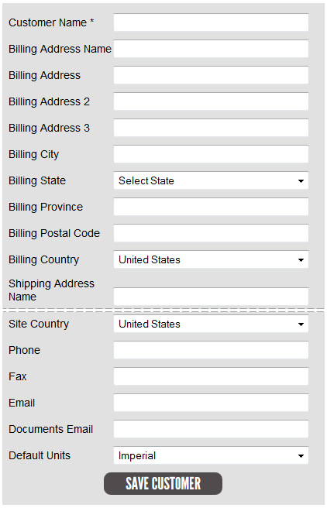
Start by entering the Customer’s name. Then, fill out the billing and shipping addresses and enter a phone number and email address. If the customer has a separate site address that should be used on calibration certificates, fill out the site address part of the form for this customer. Once you have finished filling out the form, click on the SAVE CUSTOMER button and the customer will be saved and you will be redirected to the View Customer page for the new customer.
Editing a Customer
To edit an existing customer, begin by searching for the customer, until it is listed in the customers list. Once you have found the customer you wish to edit, click on the edit icon (pencil and paper icon) on the right side of the customer record. This will bring up a form to edit the customers information. After making any changes to the customer, click on the SAVE CHANGES button and the changes you have made will be saved and you will be redirected to the View Customer page for the updated customer.
Deleting a Customer
To delete an existing customer, begin by searching for the customer, until it is listed in the customers list. Once you have found the customer you wish to delete, click on the delete icon (the x icon) on the right side of the customer record. This will bring up a confirmation box asking if you are sure you want to delete the customer. If you are sure, click on the OK button.
Managing Customer Users
To give a customer access to the customer portal in Torqueware they will need a user created and attached to that customer. To do so, select a customer to add a user to and click on the view icon (magnifying glass) to the right of that customer and it will bring up the View Customer page. Under the customer info on the right side click on the ADD CUSTOMER USER button. This will bring up a form to create a new customer user in Torqueware (see image).
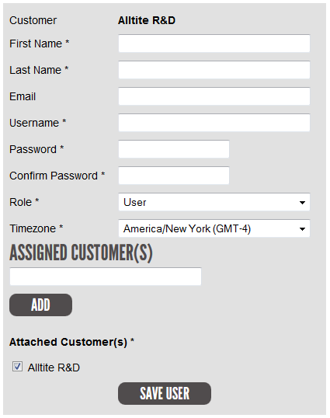
Enter a first and last name for the user. Enter an email address for the user and a username/password. Please note that the username must be unique and if you enter a username that is already in use, you will be brought back to this form and asked to enter a different username for the user when you try to save the form. Select the Role of the user. The difference between “Admin” and “User” roles for customer users is that “Admin” user roles are able to manage other users attached to the customer, while “User” role users cannot. After that, select the time zone that the user is in. If the customer user needs to be attached to more than the current customer you are adding them to, you can assign them to additional customers by entering a customer name and selecting a customer from the auto-complete list generated. Then click the ADD button and you will see the newly assigned customer in the list below. Once you have finished filling out the form, click on the SAVE USER button and you will be redirected back to the View Customer page to add more users if need be.
Editing and deleting customer users is as easy as clicking the edit or delete icons beside the customer user and making changes or confirming that you would like to delete the customer.
MANAGING TECHNICIANS
Adding a New Technician
To add a new technician, click on the TECHNICIANS link in the top main menu then, click on the ADD TECHNICIAN button in the upper right corner. This will bring up a form to create a new technician in Torqueware (see image).
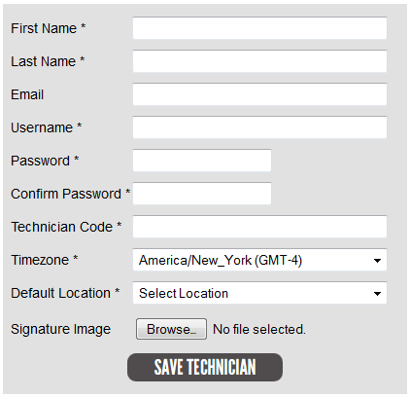
Enter a first and last name for the technician. Enter an email address for the technician and a username/password. Please note that the username must be unique and if you enter a username that is already in use, you will be brought back to this form and asked to enter a different username for the technician when you try to save the form. Then, enter a 2 digit technician code, which also must be unique. After that, select the time zone that the technician will be in and select a Default Location for the technician. Finally you will need to upload an image of the Technician’s signature which is used on calibration certificates created by the technician. The image should be at least 600 pixels wide cropped to the edges of the signature. Once you have finished filling out the form, click on the SAVE TECHNICIAN button and the technician will be saved and you will be redirected back to the technicians list.
Editing a Technician
To edit an existing technician, click on the edit icon (pencil and paper icon) on the right side of the technician record. This will bring up a form to edit the technicians information. After making any changes to the technician, click on the SAVE CHANGES button and the changes you have made will be saved and you will be redirected back to the technicians list.
Deleting a Technician
To delete an existing technician, click on the delete icon (the x icon) on the right side of the technician record. This will bring up a confirmation box asking if you are sure you want to delete the technician. If you are sure, click on the OK button.
MANAGING USERS
Adding a New User
To add a new user, click on the USERS link in the top main menu then, click on the ADD USER button in the upper right corner. This will bring up a form to create a new user in Torqueware (see image).
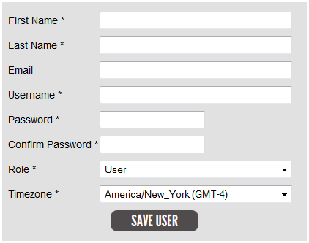
Enter a first and last name for the user. Enter an email address for the user and a username/password. Please note that the username must be unique and if you enter a username that is already in use, you will be brought back to this form and asked to enter a different username for the user when you try to save the form. Select the Role of the user. The difference between “Admin” and “User” roles for admin users is that “Admin” user roles are able to manage other users, and have the ability to add, edit and delete anything, while “User” role users cannot, and are mostly for viewing information only. After that, select the time zone that the user will be in. Once you have finished filling out the form, click on the SAVE USER button and the user will be saved and you will be redirected back to the users list.
Editing a User
To edit an existing user, click on the edit icon (pencil and paper icon) on the right side of the user record. This will bring up a form to edit the users information. After making any changes to the user, click on the SAVE CHANGES button and the changes you have made will be saved and you will be redirected back to the users list.
Deleting a User
To delete an existing user, click on the delete icon (the x icon) on the right side of the user record. This will bring up a confirmation box asking if you are sure you want to delete the user. If you are sure, click on the OK button.

MANAGING MANUFACTURERS
Adding a New Manufacturer
To add a new manufacturer, click on the MANUFACTURERS link in the top main menu then, click on the ADD MANUFACTURER button in the upper right corner. This will bring up a form to create a new manufacturer in Torqueware (see image).
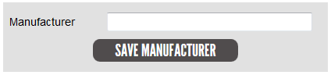
Enter the name of the manufacturer in all caps. Once you have finished filling out the form, click on the SAVE MANUFACTURER button and the manufacturer will be saved and you will be redirected back to the manufacturers list.
Editing a Manufacturer
To edit an existing manufacturer, click on the edit icon (pencil and paper icon) on the right side of the manufacturer record. This will bring up a form to edit the manufacturers information. After making any changes to the manufacturer, click on the SAVE CHANGES button and the changes you have made will be saved and you will be redirected back to the manufacturers list.
Deleting a Manufacturer
To delete an existing manufacturer, click on the delete icon (the x icon) on the right side of the manufacturer record. This will bring up a confirmation box asking if you are sure you want to delete the manufacturer. If you are sure, click on the OK button.

MANAGING LOCATIONS
Adding a New Location
To add a new location, click on the LOCATIONS link in the top main menu then, click on the ADD LOCATION button in the upper right corner. This will bring up a form to create a new location in Torqueware (see image).
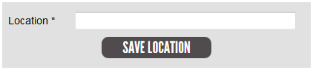
Enter the name of the location. Once you have finished filling out the form, click on the SAVE LOCATION button and the location will be saved and you will be redirected back to the locations list.
Editing a Location
To edit an existing location, click on the edit icon (pencil and paper icon) on the right side of the location record. This will bring up a form to edit the locations information. After making any changes to the location, click on the SAVE CHANGES button and the changes you have made will be saved and you will be redirected back to the locations list.
Deleting a Location
To delete an existing location, click on the delete icon (the x icon) on the right side of the location record. This will bring up a confirmation box asking if you are sure you want to delete the location. If you are sure, click on the OK button.
Managing Location Equipment
To manage location equipment, first click on the LOCATIONS link in the top main menu then, click on the MANAGE LOCATION EQUIPMENT button in the upper right corner. This will bring up a list of location equipment which you can edit or delete. To add new location equipment, click on the ADD EQUIPMENT button in the upper right corner. This will bring up a form to create a new location equipment in Torqueware (see image).
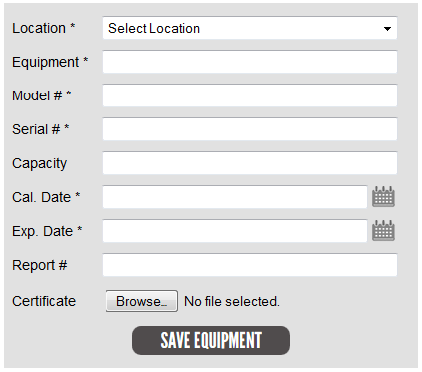
Start by selecting a location to place this equipment in. Then enter the name of the equipment, model #, serial #, and the capacity (PSI, FT-LBs, etc.). Next select the date the equipment was calibrated and when the calibration interval expires. Enter the calibration #/id for the equipment and upload a pdf of the calibration certificate for the equipment. Once you have finished filling out the form, click on the SAVE EQUIPMENT button and the product will be saved and you will be redirected back to the location equipment list.

